**PIZZA SALES INSIGHTS-DASHBOARD**

**Overview:**

This project focuses on analyzing pizza sales data to understand sales performance, customer demand, and product trends.  
It demonstrates an end-to-end data analysis process, from raw data handling to building an interactive dashboard for business insights.

The goal is to help stakeholders make better decisions related to sales strategy, product popularity, and revenue optimization.

**📂 Dataset:**

* Source: Excel file (.xlsx)
* Type: Transactional sales data
* Key fields include:
  + Order ID
  + Order Date & Time
  + Pizza Name
  + Pizza Category & Size
  + Quantity Sold
  + Unit Price
  + Total Sales Amount

**🛠 Tools & Technologies:**

* **Microsoft Excel** – Data loading and cleaning
* **MySQL** – Database storage and SQL analysis
* **SQL** – Querying, aggregations, and trend analysis
* **Power BI** – Interactive dashboard and visualizations

**Phases of project:**

**1️⃣ Data Loading**

**Imported raw pizza sales data from Excel**

**Checked data structure and column consistency**

**Data Cleaning (Excel)**

* Removed duplicate records
* Handled missing or incorrect values
* Standardized date and time formats
* Ensured correct data types for numeric fields

**Data Analysis using SQL query:**

**A.KPI’s:-**

**1.Total Revenue:-**

**\*\***select sum(total_price) AS Total_Revenue from pizza_sales

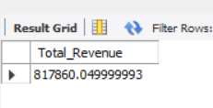

**2.Average Order Value**

**select sum(total_price)/count(distinct order_id) Avg_Order_value from pizza_sales

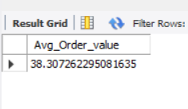

**3.Total Pizzas Sold**

**\*\*** **select sum(quantity) as Total_Pizza_Sold from pizza_sales**

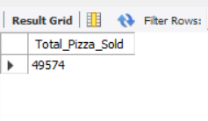

**4.Total Pizzas Order**

**select count(distinct order_id) as Total_Pizza_Order from pizza_sales

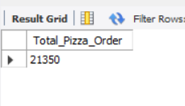

**4.Avg_Pizzas Per Order**

**select cast(cast(sum(quantity) as decimal(10,2)) /cast(count(distinct order_id) as decimal(10,2)) as decimal(10,2)) as Avg_Pizza_Perorder from pizza_sales

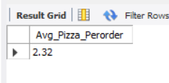

**B.Charts Requirement:-**

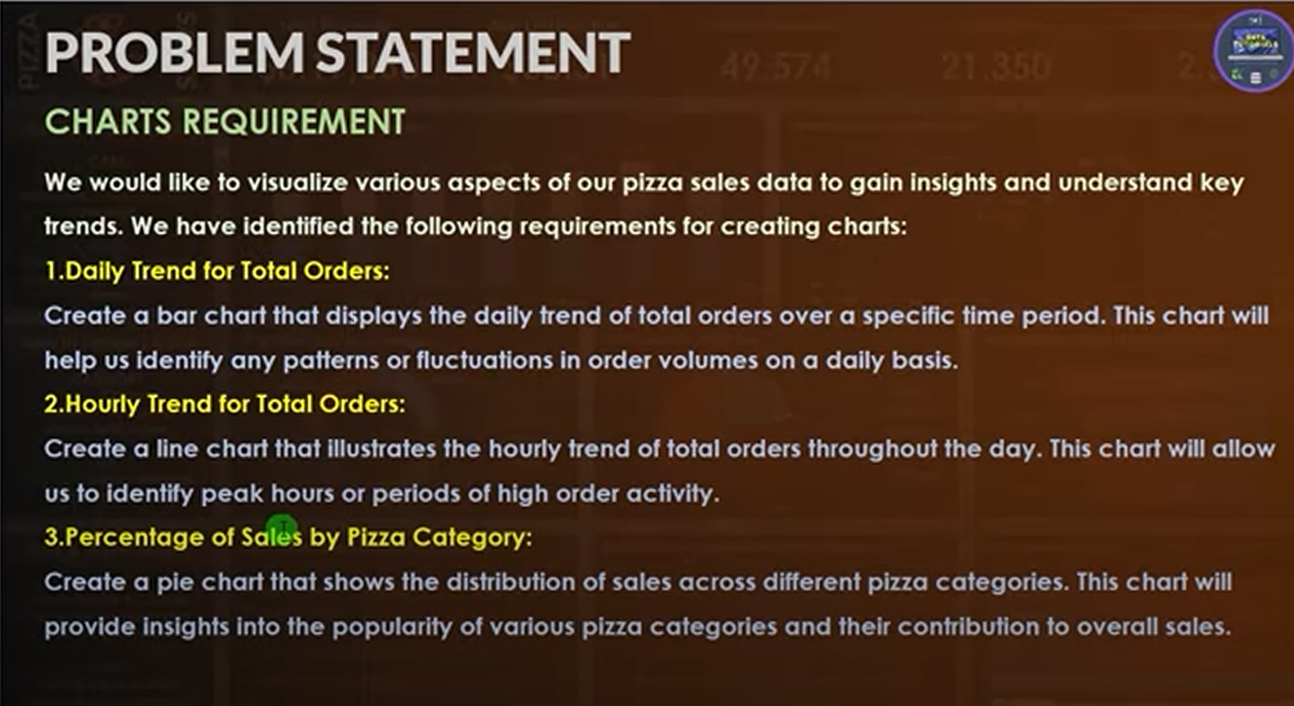

**1.Daily Trend for Total Orders:**

**\*\***select Dayname(str_to_date(order_date,'%d-%m-%Y')) as Order_Day ,

count(distinct order_id) as Total_Orders

from pizza_sales

group by Dayname(str_to_date(order_date,'%d-%m-%Y'));

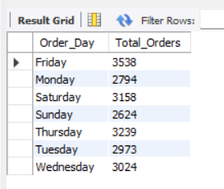

**2.Hourly Trend for TotalOrders:**

select monthname(str_to_date(order_date,'%d-%m-%Y')) as Month_Name, count(distinct order_id) as Total_orders

from pizza_sales

group by monthname(str_to_date(order_date,'%d-%m-%Y'))

order by Total_orders desc;

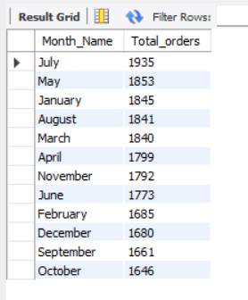

**3.Percentage of Sales by Pizza Category:**

* select pizza_category,sum(total_price)*100/ (select sum(total_price) from pizza_sales) as pct_Total_Sales
* from pizza_sales
* group by pizza_category;

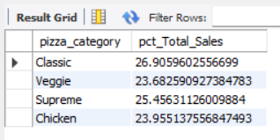

----**ORDERS OF HIGHEST CATEGORY OF PIZZA**------------------------------------------------------------------------

select pizza_category,sum(total_price) as Total_sales,sum(total_price)*100/ (select sum(total_price) from pizza_sales where monthname(str_to_date(order_date,'%d-%m-%Y')) = 'January') as pct_Total_Sales

from pizza_sales

group by pizza_category

select pizza_category,sum(total_price) as Total_sales,CAST(sum(total_price)*100/ (select sum(total_price) from pizza_sales where monthname(str_to_date(order_date,'%d-%m-%Y')) = 'January') AS DECIMAL(10,2))as pct_Total_Sales

from pizza_sales

group by pizza_category

ORDER BY pct_Total_Sales desc ;

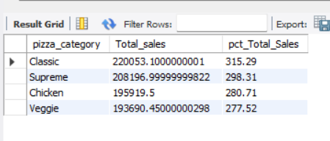

select pizza_size,cast(sum(total_price) as decimal(10,2)) as Total_sales,CAST(sum(total_price)*100/ (select sum(total_price) from pizza_sales where monthname(str_to_date(order_date,'%d-%m-%Y')) = 'January') AS DECIMAL(10,2))as pct_Total_Sales

from pizza_sales

group by pizza_size

order by pct_Total_Sales;

* ORDER BY pct_Total_Sales desc ;
* 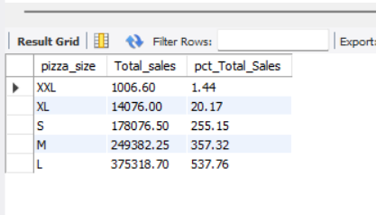
* 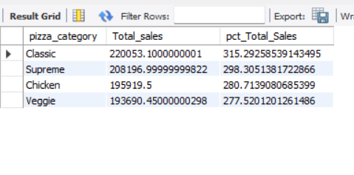

**----EXAMPLES----**Sales only in month of January

* select pizza_category,sum(total_price) as Total_sales,sum(total_price)*100/ (select sum(total_price) from pizza_sales) as pct_Total_Sales
* from pizza_sales
* where monthname(str_to_date(order_date,'%d-%m-%Y')) = 'January'
* group by pizza_category;

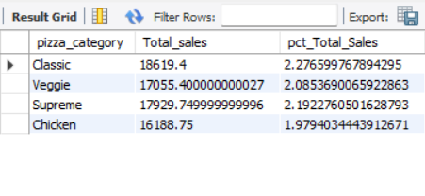

------Where clause should use with subquery

select pizza_category,sum(total_price) as Total_sales,sum(total_price)*100/ (select sum(total_price) from pizza_sales where monthname(str_to_date(order_date,'%d-%m-%Y')) = 'January') as pct_Total_Sales

from pizza_sales

* + **group by pizza_category;**

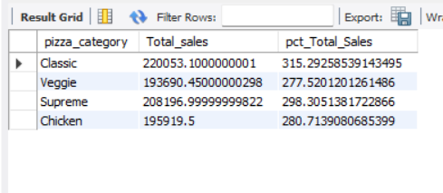

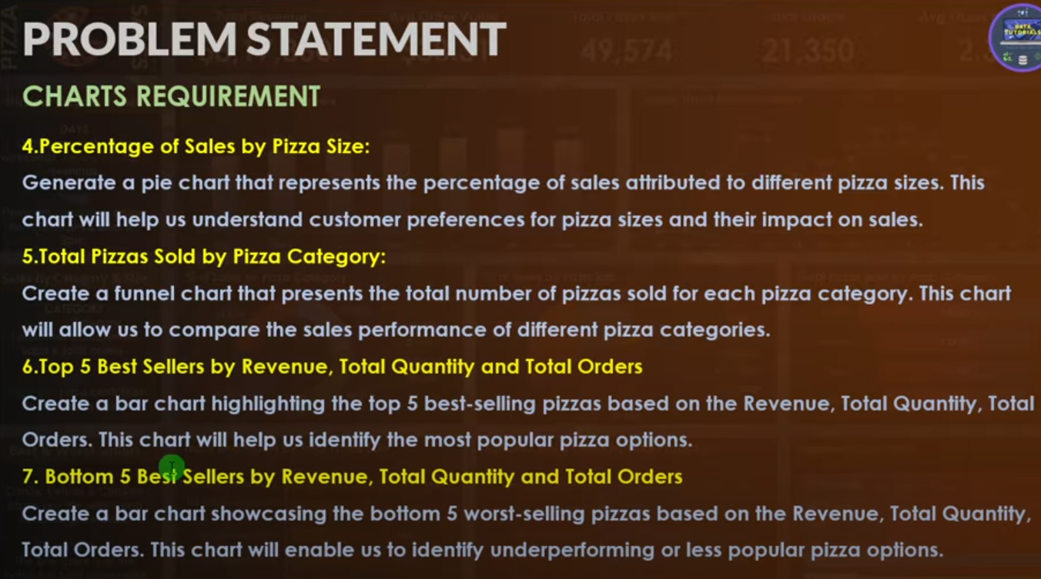

6.**Top 5 Best sellers by revenue(total_sales),total quantity and total orders**

**select pizza_name,sum(total_price) as Total_Revenue**

**from pizza_sales**

**group by pizza_name**

**order by Total_Revenue desc**

**limit 5;**

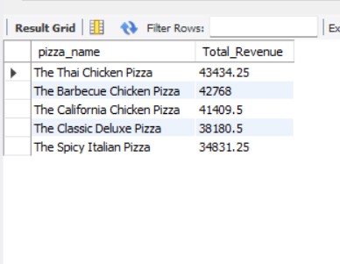

**Bottom 5 -------**

**select pizza_name,sum(total_price) as Total_Revenue,sum(quantity) as Total_quantity,count( distinct order_id) as Total_Orders**

**from pizza_sales**

**group by pizza_name**

**order by Total_Revenue ,Total_quantity,Total_Orders asc**

**limit 5;**

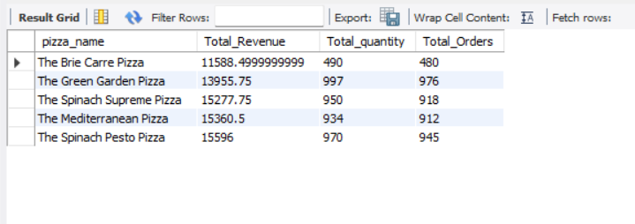

Powerbi query

B.EDA

1.Load data from mysql database

2.Data Cleaning

* Pizza size-L,M,XXL---gives full name
* **Home-transform data-power query**
* **Select-pizza_size-right click-replace values [L-Large,M-Medium,XL-X-Large…**
* **Close and apply**

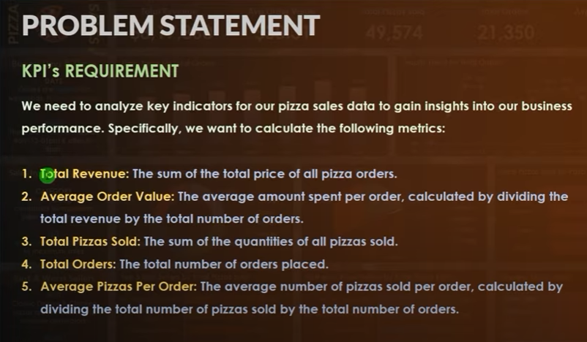

* USE DAX FUNCTION
* RIGHT CLICK ON ANY ATTRIBUTE-MEASURE
* **1.Total_Revenue = sum( 'pizza_shops pizza_sales'[total_price])**
* **4.Total_Orders = DISTINCTCOUNT( 'pizza_shops pizza_sales'[order_id])**
* **2.Avg Order Value = [Total_Revenue]/[Total_Orders]**
* **3.Total Pizzas Sold = sum('pizza_shops pizza_sales'[quantity])**
* **5.** **Avg Pizzas Per Order= [Total Pizzas Sold]/[Total_Orders]**
* Go to Visuals-New Card-Create KPI
* 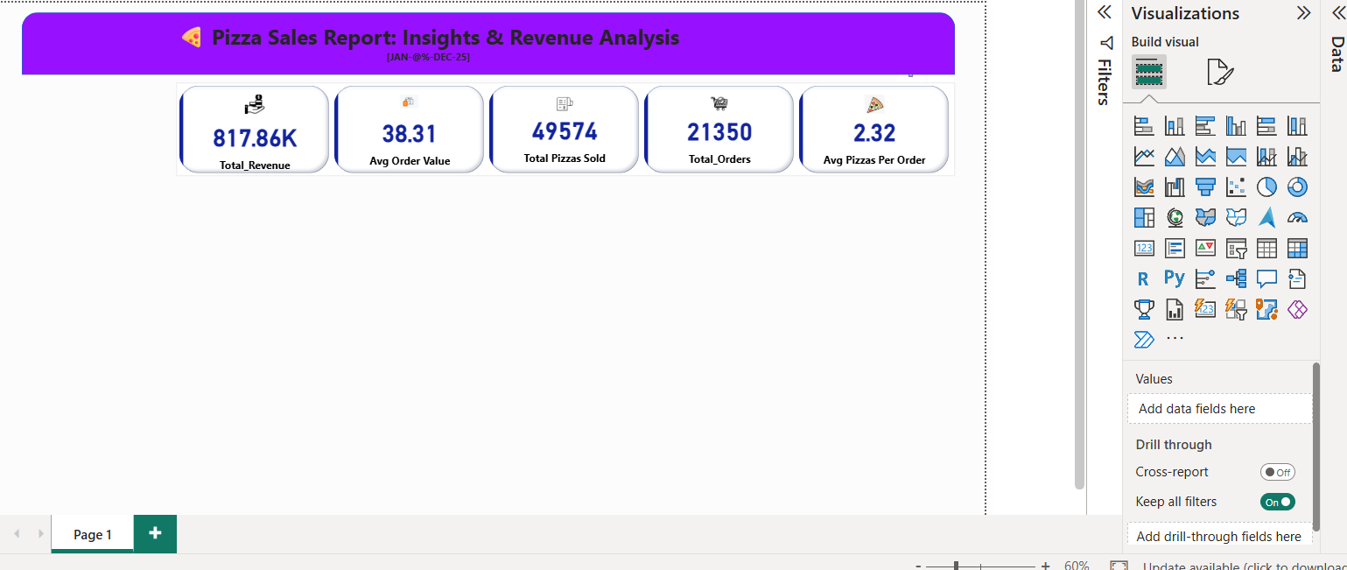
* Create Charts
* 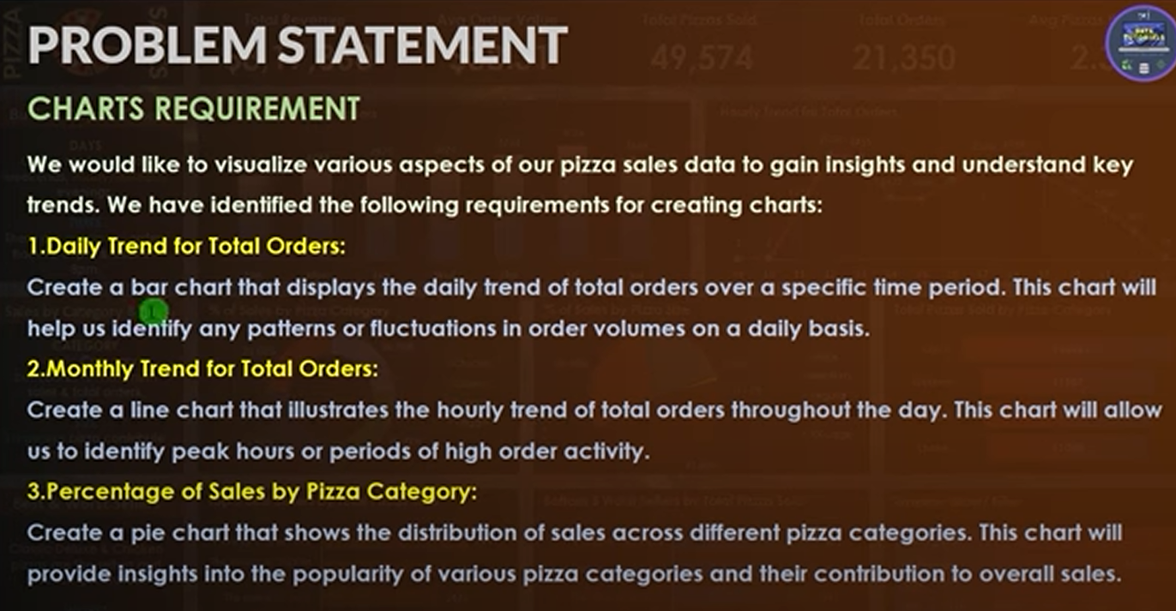
* 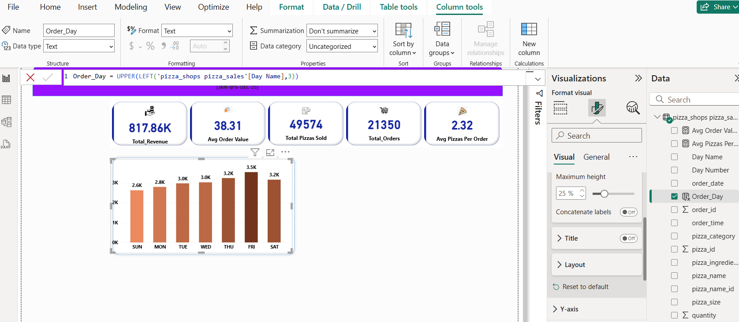
* 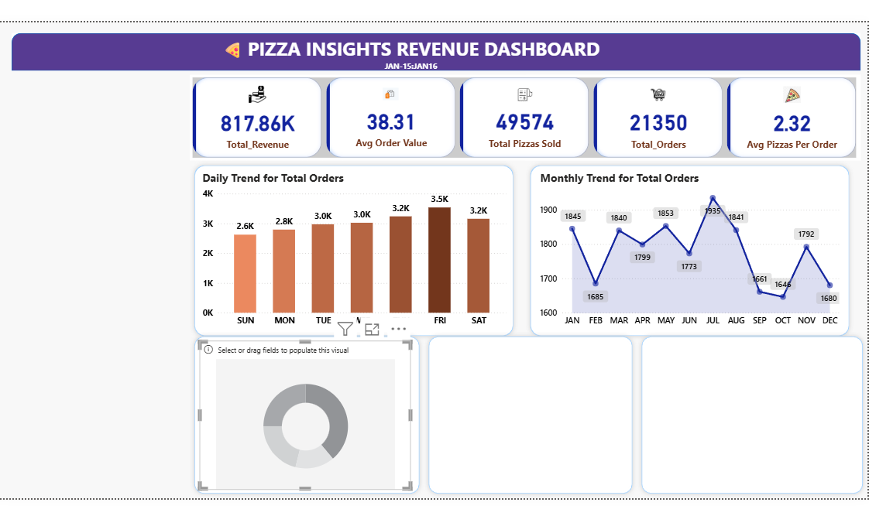
* Total Revenue by pizza category
* X-axis-Pizza category
* Y-axis-Total revenue
* Total Revenue by pizza Size
* X-axis-Pizza Size
* Y-axis-Total revenue
* ----rotation -2%
* 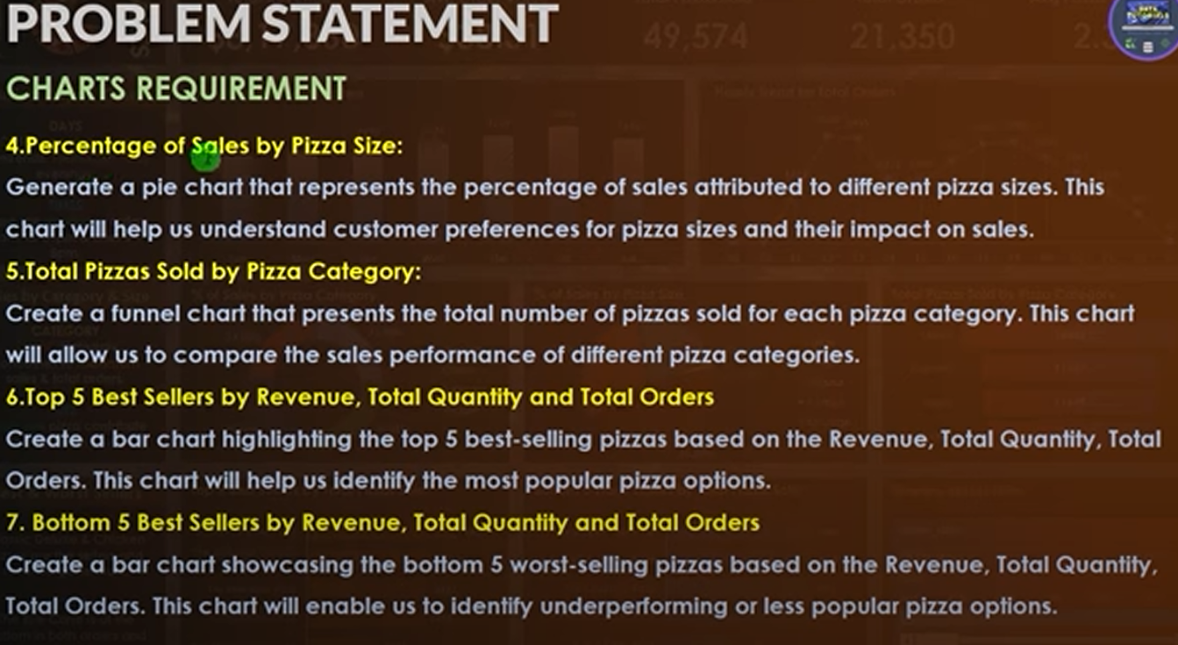
* % of sales by pizza sale
* X-axis-
* Y-axis-

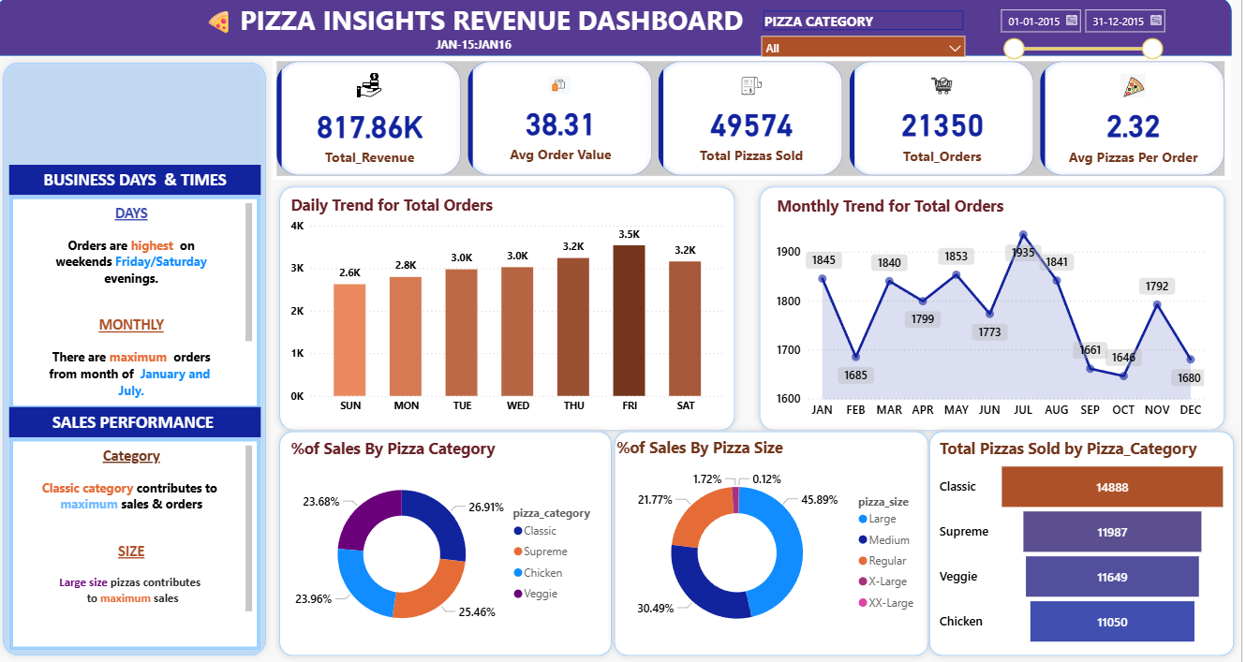

---------------------------------------------------------------------------NEXT PAGE-BEST/WORST SELLERS

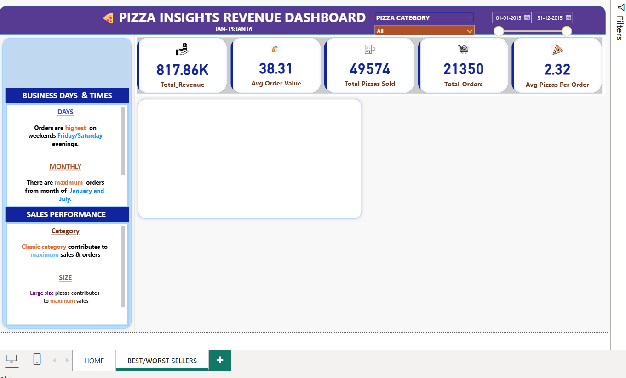

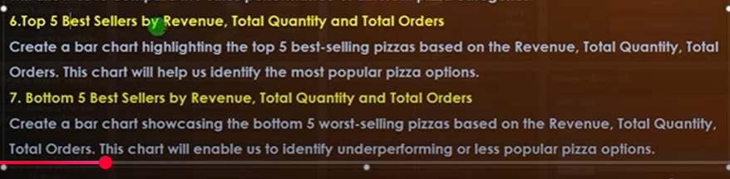

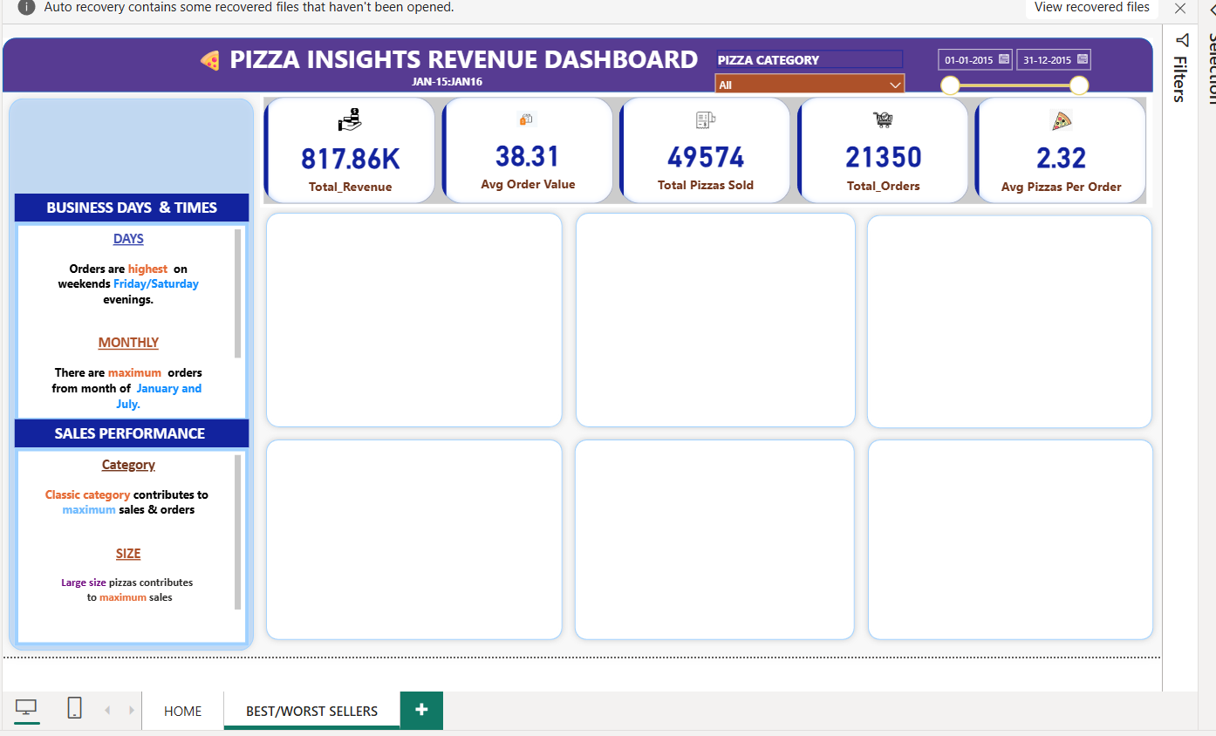

--TOTAL SELLERS BY REVENUE

---BAR CHART

X-AXIS=PIZZA NAME,Y-AXIS==TOTAL REVENUE

FILTER SECTION

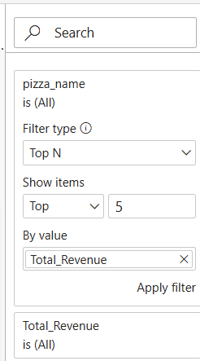 APPLY FILTER

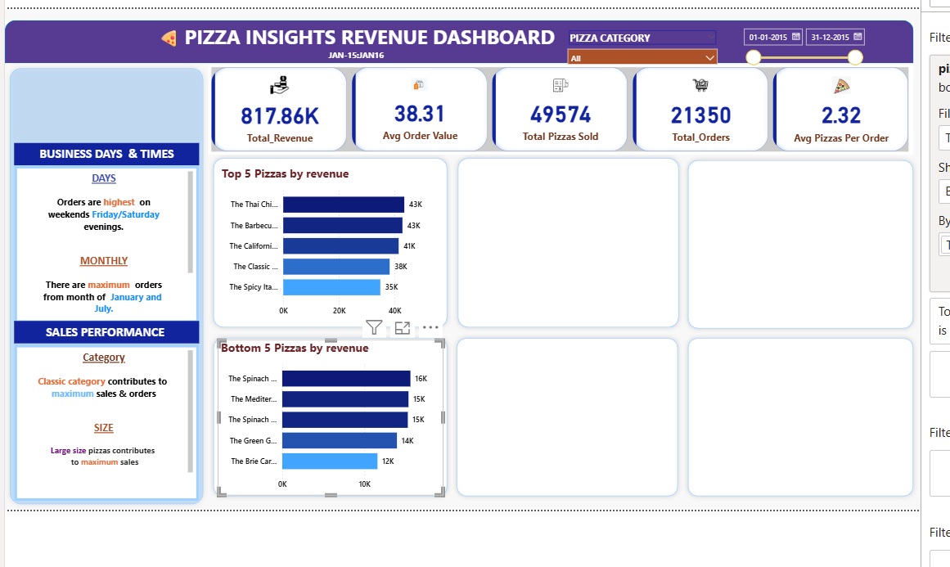

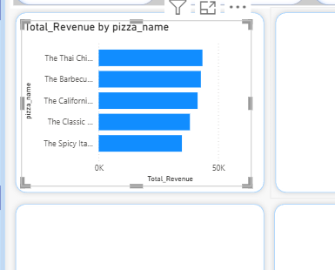

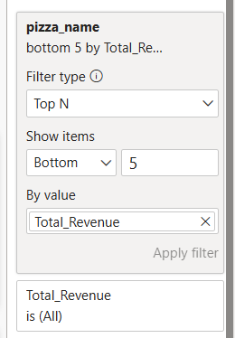

**Business Recommendation:**

1. **Focus on Top-Selling Pizzas:** Use top performers as anchor products to increase overall order value.
2. **Improve Low-Performing Pizzas:** Review pricing, ingredients, or visibility of low-selling pizzas.
3. **Leverage Pizza Size & Category Insights:** Adjust pricing strategy for sizes that generate higher margins.
4. **Data-Driven Inventory Planning:** Reduce food waste by aligning procurement with actual demand.
5. **Use Dashboard for Ongoing Monitoring:** Track daily revenue and order volume using KPI cards.